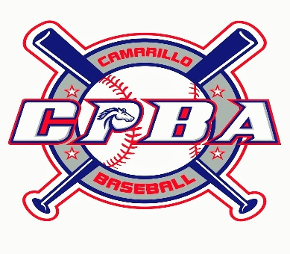
2024 Sponsorship Opportunities
Annual  Sponsorship  Incentives | SINGLE  $125 | DOUBLE  $250 | TRIPLE  $500 | HOMERUN  $1000 | GRAND SLAM  $1500
CPBA  Hat  (Adjustable Back) | x | x | x | x | x
Appreciation Plaque |  | x | x | x | x
Advertising Banner  (Banner Placement On Website AND Backstops Near Kildee Fields Snack Bar. Special Acknowledgement at Opening And Closing Ceremonies) |  |  | x | x | x
Special Advertising  (Specific Email Sent To ALL CPBA Families AND Recognition On ALL Of Our Social Media Platforms) |  |  |  | x | x
Division Branding  (Company Name/Logo On Sleeve Of ALL Uniforms Of Selected Division) |  |  |  |  | x
YES!! Please include me as a Sponsor for Camarillo Pony Baseball!
☐ Single ☐ Double ☐ Triple ☐ Homerun ☐ Grand Slam

Name of Company: ______________________________ Contact Person: ____________________________
Address: __________________________________ City: ______________State: ________Zip: ___________
Phone: _______________ Email: ______________________ Website Address: ___________________

Please send this form and payment to:
Camarillo Pony Baseball Association, Attn: Sponsorships
PO Box 2814, Camarillo, CA 93011
Checks can be made payable to: Camarillo Pony Baseball Association
Our tax ID # is 95-3585562.
*THESE ARE ANNUAL SPONSORSHIPS*

